Scenario:

Frontier airlines sells seats on its flights for two prices: $195 and $235. It starts accepting reservations at $195, and then once it has sold a sufficient number of seats, it increases prices to $235 and attempts to sell all the remaining seats. Past experience shows that if they kept prices at $195, the plane would be full.

The airline knows some last-minute customers will be willing to pay $235 for a seat, but the number of customers willing to pay $235 varies from day to day. The airline has some historical data on the number of seats it has sold at $235. You have been asked to help Frontier figure out how many seats it should hold in reserve at the $235 price in order to maximize profit.

Answer the following:

1. For this scenario:
2. What do you need to decide?

We need to decide/define the maximum number of Seats we need to allocate for $235 price. So, that we maximize the profit of Airline

1. What key performance indicators do you need to consider?

The KPI to consider are:

* + The Profit should not be less than the profit what we would make if we keep $195 price for all seats.
  + The number of seats not utilized/reserved should be minimal

1. Using the supplied Excel workbook, generate an analysis that shows the following:

* Minimum and maximum values for number of seats sold at $235

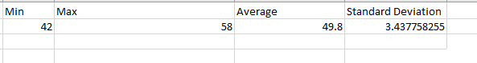

* A frequency table for seats sold at $235

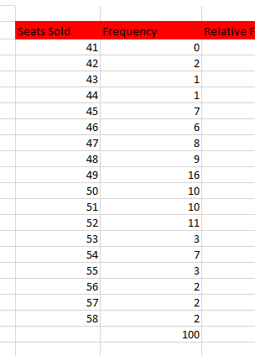

* Cumulative probabilities (probability demand ≥ N) at each level of seat demand

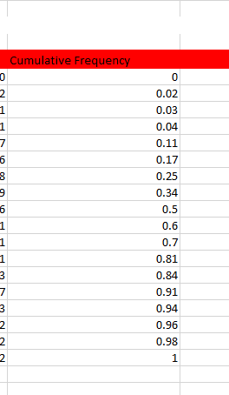

* Expected marginal revenue at each level of seat demand

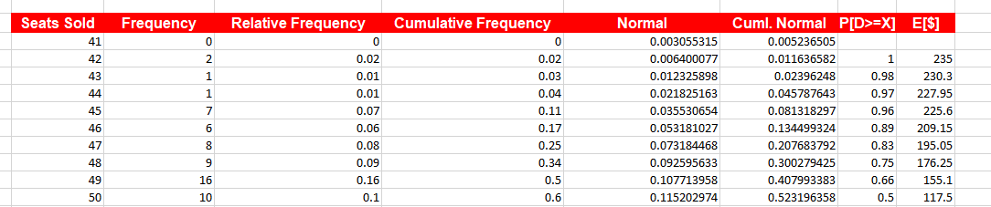

Include the Excel workbook in your submission to your instructor.

1. Based on your marginal analysis, how many seats should Frontier sell at $235? Explain the reasoning behind your recommendation.

Based on the expected Marginal revenue derived, Frontier should not sell seats between 42 to 47 to maximize the Profit margin